**Books.Toscrape Webside WebScrapping**

**A Project Submitted to the**

**IT VEDANT Institute, Thane.**

**Data Science & Data Analytics With AI**



**Python-Web-Scrapping Project**

**BY**

**Prerana Vijay Rokade**

**Under the Guidance of**

**Mr. Sameer Warsolkar**

#### Description:

The project involves scraping book information from the "Books to Scrape" website. The extracted data includes the title, price, and rating of each book listed on the site's first page. This information is displayed in a table format using PrettyTable, saved into a CSV file, and visualized using a scatter plot to show the relationship between book prices and ratings.

#### Outline:

1. **Choose the Website and Webpage URL**
2. **Inspect the Website**
3. **Install the Important Libraries**
4. **Write the Python Source Code**
5. **Export the Extracted Data**

#### Steps:

#### 1. Choose the Website and Webpage URL

* **Website:** Books to Scrape
* **URL:** <http://books.toscrape.com/>

#### 2. Inspect the Website

* Use browser developer tools (right-click on the webpage and select "Inspect" or press Ctrl+Shift+I).
* Identify the HTML structure containing the book details: book titles, prices, and ratings.

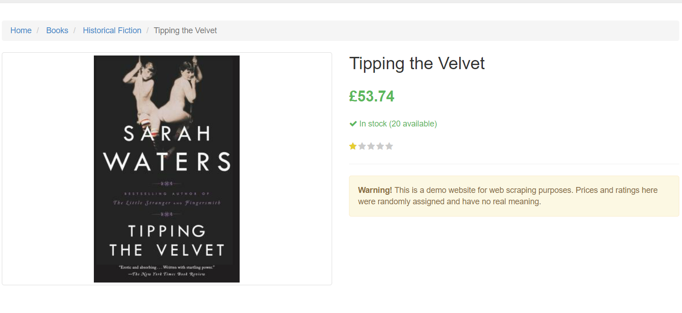

#### Benefits and Risks:

#### Benefits:

1. **Automated Data Collection:**
   * **Efficiency:** Automates the repetitive task of manually collecting book data, saving time and reducing human error.
   * **Scalability:** The script can be extended to scrape additional pages or more complex websites with minimal changes.
   * **Consistency:** Ensures consistent data collection, reducing the likelihood of missed information or inconsistencies.
2. **Data Analysis:**
   * **Structured Data:** Outputs data in a CSV format, which is a widely used and versatile format for data analysis and reporting in various tools and environments.
   * **Visualization Ready:** The structured format makes it easy to visualize data using other tools or libraries if needed.
3. **Skill Development:**
   * **Technical Proficiency:** Enhances understanding and proficiency in web scraping, data parsing, and data handling using Python libraries.
   * **Problem-Solving:** Provides experience in solving real-world problems related to web data extraction and automation.
4. **Adaptability:**
   * **Versatile Application:** The techniques used can be adapted to scrape various types of websites and data, making the skillset broadly applicable.

#### Risks:

1. **Legal and Ethical Issues:**
   * **Terms of Service Violations:** Scraping data from websites without permission may violate their terms of service and lead to legal consequences.
   * **Data Privacy:** Extracting personal or sensitive data without consent can lead to privacy violations and ethical concerns.
2. **Technical Challenges:**
   * **Website Changes:** Websites can change their structure, breaking the scraping script and requiring frequent updates.
   * **IP Blocking:** Frequent scraping requests can lead to the IP address being blocked by the website, disrupting data collection.
3. **Data Quality:**
   * **Inaccurate Data:** Extracted data may be incomplete or inaccurate if the scraping script fails to handle all edge cases correctly.
   * **Misinterpretation:** Incorrectly parsing or interpreting data can lead to misleading conclusions and analyses.
4. **Resource Intensive:**
   * **System Load:** Large-scale scraping can be resource-intensive, consuming significant amounts of bandwidth and processing power.
   * **Maintenance:** Requires ongoing maintenance to ensure the scraping script adapts to changes in the target website’s structure.

#### books.toscrape Web Scraping Coding

### Step-by-Step Guide:

#### 1. Import Required Libraries

First, you need to import all the necessary libraries for the task. These include requests for making HTTP requests, BeautifulSoup for parsing HTML content, csv for writing data to a CSV file, re for regular expressions, and PrettyTable for displaying data in a table format.

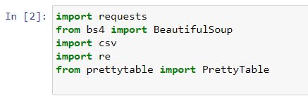

#### 2. Define the URL of the Website to Scrape

Specify the URL of the website you want to scrape. In this case, it's the "Books to Scrape" website.

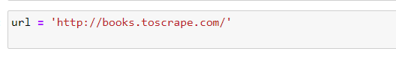

#### 3. Define the Function to Scrape the Webpage

Create a function called scrape_books that takes a URL as an argument, sends an HTTP GET request to that URL, and parses the HTML content to extract book information.

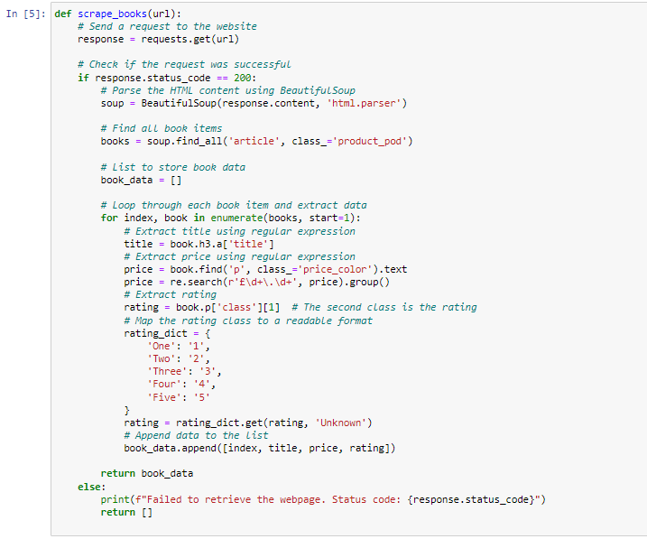

#### 4. Scrape the Books from the First Page

Call the scrape_books function with the specified URL to get the book data.



#### 5. Display the Data in a Tabular Format Using PrettyTable

Create a PrettyTable object, define the column headers, and add the extracted book data to the table.

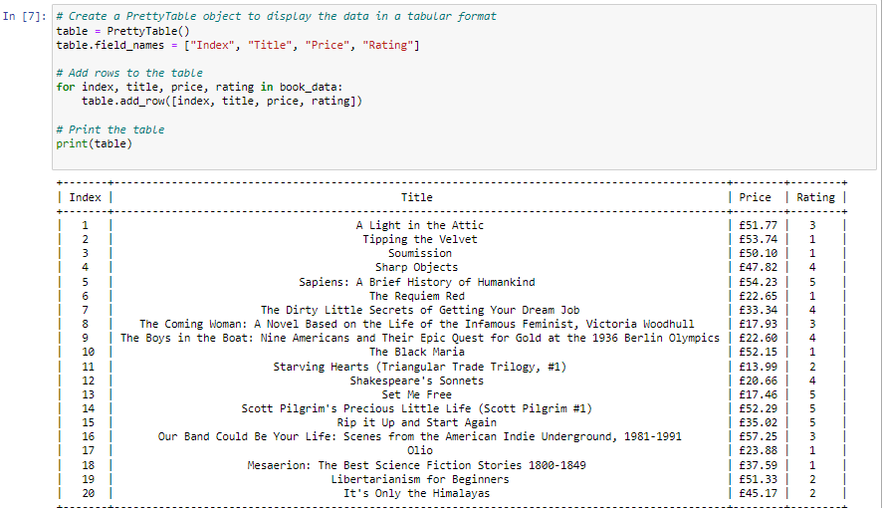

#### 6. Save the Data to a CSV File

Open a new CSV file in write mode and write the extracted book data to it.

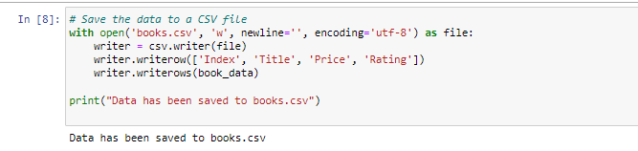

### Conclusion:

By following these steps, you can automate the process of scraping book information from a website, display the data in a readable format using PrettyTable, and save the data into a CSV file for further analysis or reporting. This script provides a solid foundation for web scraping tasks and can be extended to handle more complex scenarios.

THANK YOU